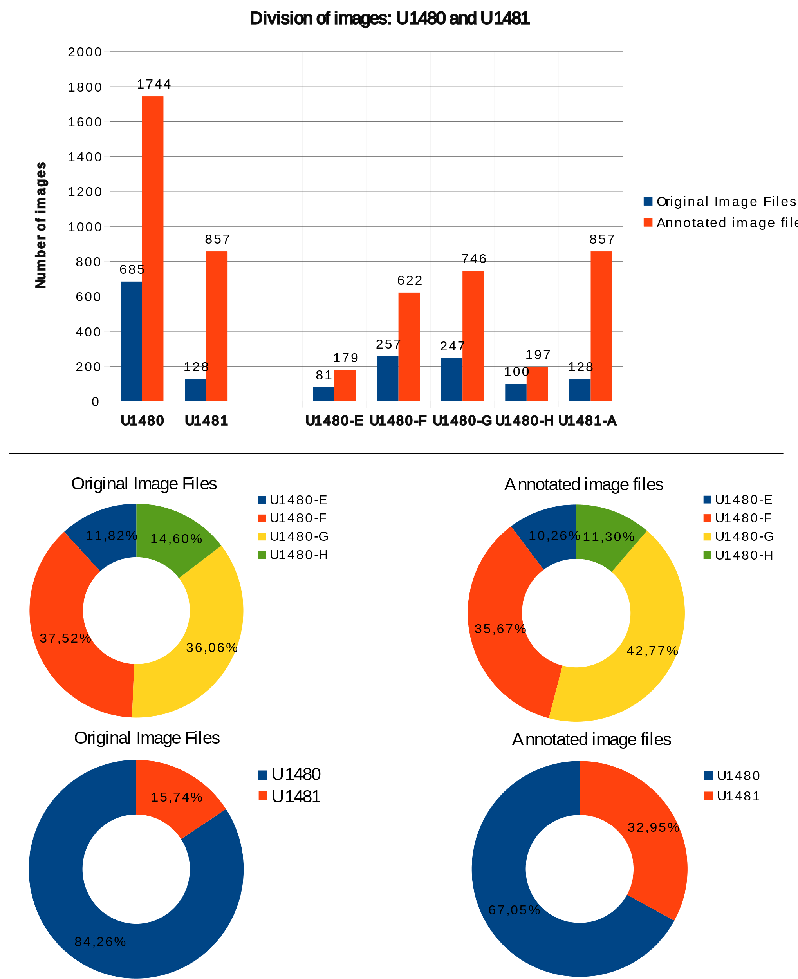

Figure 1 Summary of the composition of the original images and images annotated by site U1480 and site U1481 and holes E, F, G and H to U1480 and A to U1481. Original images are files acquired directly from the expedition, in high-resolution format. Annotation images are files created from the original images through annotation as described in chapter 2.3.